NATIONAL RESTAURANTEXCHANGE

*(617)721-9655*

DSerpone@comcast.net

# LISTING INFORMATION

**HOT~HOT DAVIS SQ. area, Somerville~TUFTS College~~Casual Italian Take-Out (Pizza, Subs, Wraps, Pasta)**

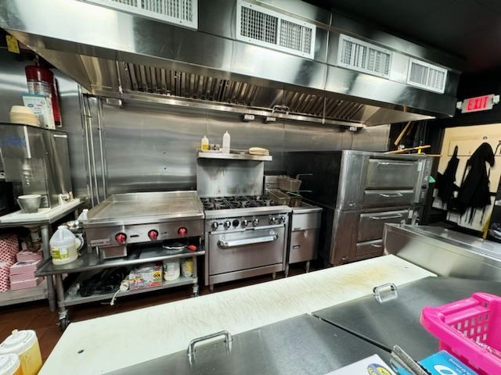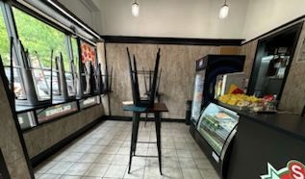

*(stock photos)*

**SELLING PRICE:** $225K SBA financing readily available with 10% down

**SALES VOLUME: Strong** $11K per wk..............60% Delivery

**LEASE: $2,675/mo. includes NNN (only 5% of sales)**

**Yearsleft**: 2.25 years + 5 years option to renew

**SQUARE FOOTAGE:**1,170

**HOURS OF OPERATION:** 6 days…Wednesday-Monday 11am-Midnight

**SEATING:** 10

**COMMENTS: Davis Sq. is a major food & beverage mecca…the area draws from EVERYWHERE. This is a clean, simple operation with a strong repeat customer base.**

**The place lacks ‘personality’. Your investment will be back in your pocket within a couple of years. Check out the facility, go over the books…this is a rare opportunity to be part of the DAVIS SQUARE mystique.**

**Call John at781-858-2343 or email: jkruggie@comcast.net**