NATIONAL RESTAURANTEXCHANGE
(617)721-9655
DSerpone@comcast.net

LISTING INFORMATION
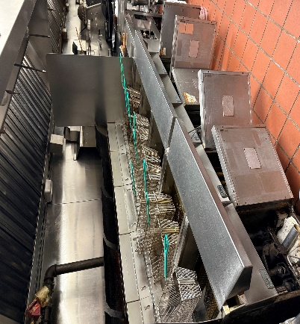
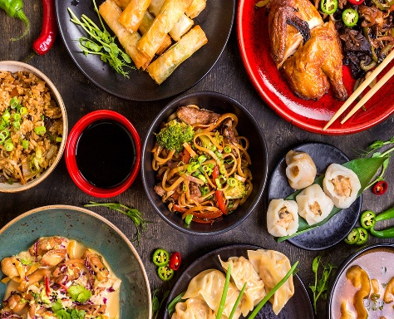

NORTH SHORE~~UPSCALE PRISTINEChinese Restaurant that
could be converted to any concept.

SELLING PRICE: $1,000,000 w/extensive real estate at Fair Market Value!
DOWN PAYMENT: Readily financed by SBA w/only 10% down.
VERIFIABLE NET PROFIT = $500,000/yr.
SALES VOLUME: STRONG, consistent sales of $50K/wk. ($2.5M - $2.9M/yr.)

SQUARE FOOTAGE:footprint of 5,000sf w/ an amazing 5,000sf of a clean dry basement for prep and storage with six walk-ins. Bldg. is fully alarmed and sprinkled.

HOURS OF OPERATION: 6 days, 11am-9pm… Tues. – Sun.

SEATING: 255 seats for dinner, bar area and function room.

REASON FOR SELLING:Retiring after over 30 yrs.

COMMENTS: This exceptionally well-maintained restaurant offers everything needed for continued success. The full-service Chinese facility includes a full liquor license, parking for 75 cars, a separate lounge area with TVs, modern bathrooms, and first-rate equipment in excellent condition. Real estate is included in the sale price. Located at a major intersection on a heavily traveled road connecting to several numbered routes; the property offers strong visibility and easy access. The simple décor allows the space to be easily converted to almost any concept.
Buy the business for $900K and FAIR MARKET VALUE FOR THE REAL ESTATE
NDA required…only seasoned operators and financially qualified need apply.

Contact John Ruggieri at 781-858-2343 or jkruggie@comcast.net.

