NATIONAL RESTAURANTEXCHANGE
978-715-5405 FAX : 339-988-3927
neresraurants@yahoo.com

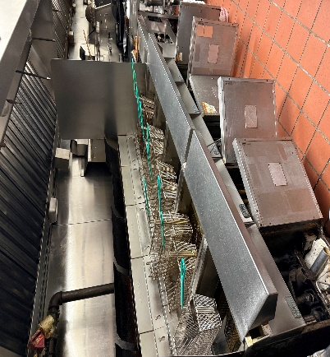


TYPE OF BUSINESS: Chinese Restaurant that could be converted
to any concept you want
LOCATION: North Shore

SELLING PRICE: $4,500,000 w/Real Estate

DOWN PAYMENT: 10% w/ SBA

SALES VOLUME: $50k/wk.

SQUARE FOOTAGE: 5,000sf. w/ an amazing clean dry basement for prep and storage with six walk-ins.

HOURS OF OPERATION: 11-9 Tues. – Sun.

SEATING: 255 inside

REASON FOR SELLING: Retiring

COMMENTS: This exceptionally well-maintained restaurant offers everything needed for continued success. The full-service Chinese facility includes a full liquor license, parking for 75 cars, a separate lounge area with TVs, modern bathrooms, and first-rate equipment in excellent condition. Real estate is included in the sale price. Located at a major intersection on a heavily traveled road connecting to numbered routes, the property offers strong visibility and easy access. The simple décor allows the space to be quickly converted to almost any concept. For more information, Call John at781-858-2343 or email: jkruggie@comcast.net

