NATIONAL RESTAURANT EXCHANGE
(617)721-9655 (781)246-5000
DSerpone@comcast.net DenSerpone@gmail.com

LISTING INFORMATION

SHARON- area~~BREAKFAST and LUNCH LANDMARK
“It’s time to retire!”

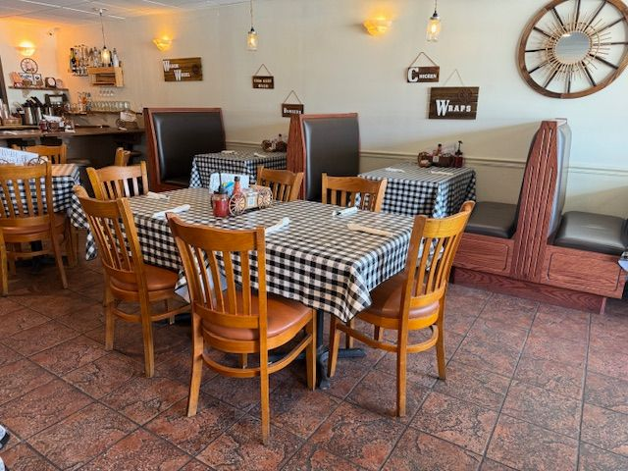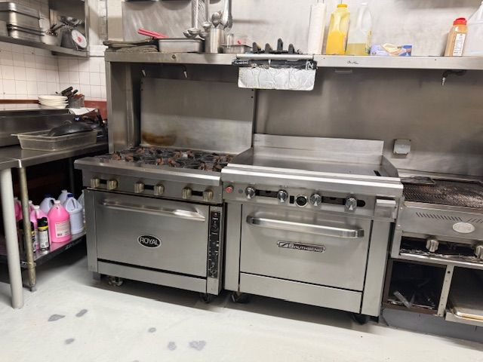

SELLING PRICE: $225K DOWN PAYMENT: $100K

SALES VOLUME: $7K/wk ($371K/yr.)

LEASE: $3K/mo. (includes NNN)

SQUARE FOOTAGE: 2,000 sf.

SEATING: 50 seats

HOURS OF OPERATION: 7Am – 2 PM

COMMENTS: BREAKFAST & LUNCH are the MOST PROFITABLE segments of food & beverage industry. This is an exceptionally clean and inviting facility for families…or eating alone. Great location with extensive parking with minimal competition.

Call Gina at 860-490-4483 or ginavarvelli@gmail.com.

