NATIONAL RESTAURANT EXCHANGE
617-721-9655

LISTING INFORMATION

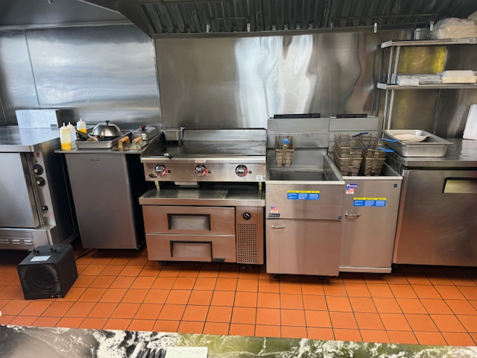

TYPE OF BUSINESS: POPULAR ROAST BEEF & SEAFOOD TAKE-OUT

LOCATION: Wakefield area. Main busy Rte.

SELLING PRICE: asking $100K DOWN PAYMENT: $50K

SALES VOLUME: $8K/wk . Pick-up Take-out only.

LEASE: $1750.00 ALL IN. YRS. LEFT: 6 years with a 5 year option

SQUARE FOOTAGE: 650 sf.

HOURS OF OPERATION: 11AM - TO 9AM Mon-Sat Closed Sunday.

SEATING: No Seating pick-up Take-out only.

COMMENTS: Excellent, neat as a pin Roast Beef & Seafood, pick-up / take-out business in a great location. The food is fantastic. Everything is brand new, Hood, Line, and all equipment. All the gas equipment is outfitted with quick releases for that extra clean line. Could be an easy concept change if desired, to Take-out Pizza, Wraps, and Hot Dogs etc.
Call Mr. Williams @ 978-715-5405 or email nerestaurants@yahoo.com for more details.
Owner has decided to retire after many years in the business.

