NATIONAL RESTAURANT EXCHANGE
(617)721-9655 (781)246-5000
DSerpone@comcast.net DenSerpone@gmail.com

FRANKLIN area~ BIG & BEAUTIFUL BREAKFAST & LUNCH
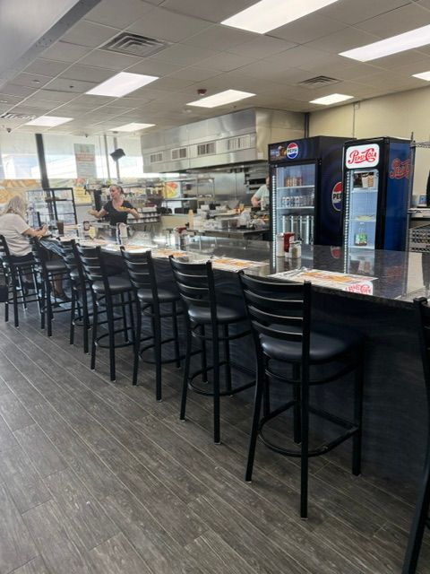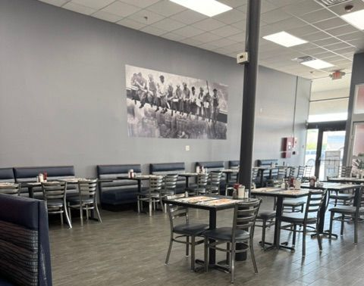
SELLING PRICE: $295K DOWN PAYMENT: $150K or only $30K
if you qualify for a SBA loan.

SALES VOLUME: $18K - $20K/wk.

LEASE: $7K/mo. (includes NNN) YRS. LEFT: 5+5

SQUARE FOOTAGE: 6,000sf.

SEATING: 80 seats plus 12 at the lunch counter

HOURS OF OPERATION: 6 AM -2 PM, closed Mondays.

REASON FOR SELLING: Serious health issues

VERIFIABLE ANNUAL NET INCOME: $200,000+

COMMENTS: Over $600,000 was spent building out the restaurant with all NEW EVERYTHING! There has been no marketing, of any kind, due to health. If you’re a seasoned breakfast cook or manager, this place is perfect. There’s a huge student population within a mile…advertise specials to the students with flavored coffees and smoothies and you’ll double your profits. Located in a large shopping center with great visibility and parking. Nothing is more profitable than BREAKFAST & LUNCH!

Call Bob to see at: 781-820-9288 or bobcioffi14@gmail.com

