NATIONAL RESTAURANTEXCHANGE
(617)721-9655 Fax: (781)246-5000
DSerpone@comcast.net

LISTING INFORMATION

NEWTON CLOSED- FAST CASUAL specializing in pizza, sandwiches, and dinners to go.
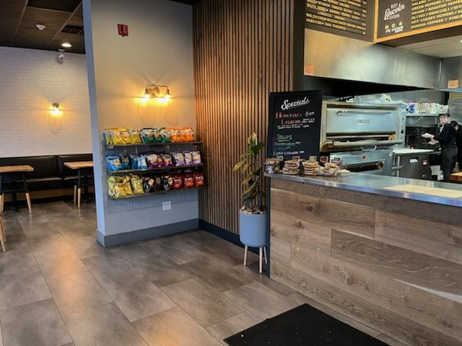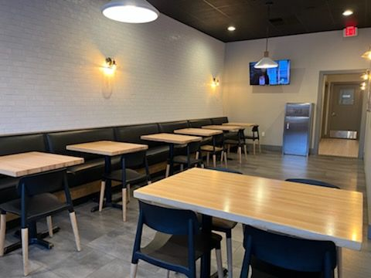
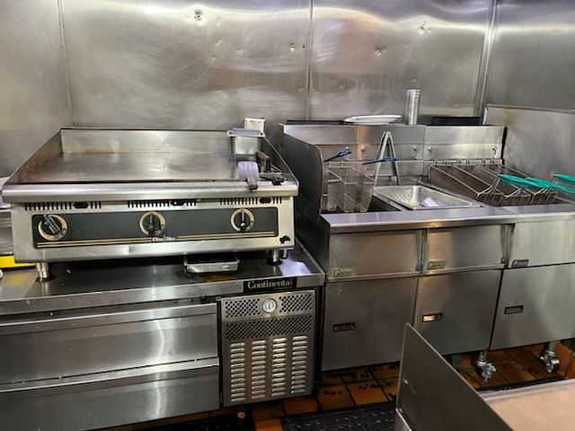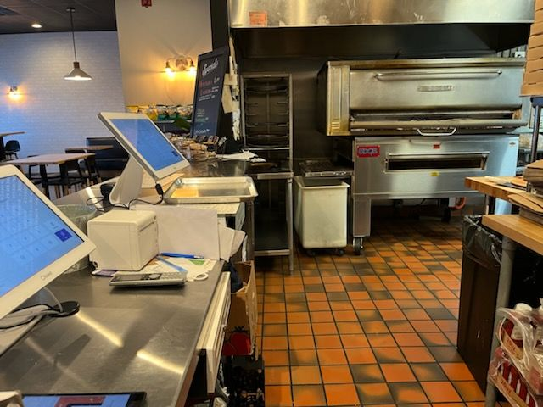
SELLING PRICE: $150K ALL CASH

SALES VOLUME: CLOSED

LEASE: $6,000/mo. + NNN

Years left: New Lease 5+5

SQUARE FOOTAGE: 2,300sf. + full dry basement with walk-in refrigeration

HOURS OF OPERATION: CLOSED

SEATING: 30 seats (inside) 8 seats (outside)

HOURS OF OPERATION: 7days, 11 am – 9 pm

COMMENTS: This is an amazing build-out with enough equipment to handle any menu.
You’ll be amazed at the quality of the design and choice of equipment. This Business did net over $125K/yr. with the original owner can do much more with seasoned operator.
Newton is one of the most affluent markets in Mass. Your cash investment is returned in the first year. Call John at 781-858-2343 or email at jkruggie@comcast.net.

