The National Restaurant Exchange

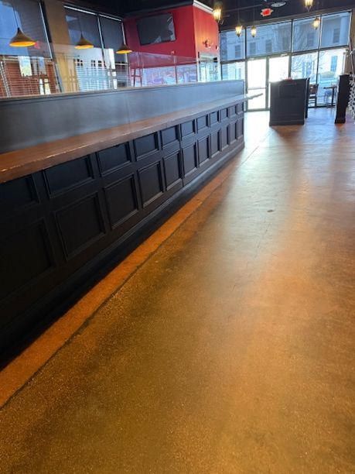

NASHUA-SALEM, NH area BIG, BEAUTIFUL BAR WITH FUNCTION SPACE

SELLING PRICE: a STEAL at $195K DOWN PAYMENT: only $100k

SALES VOLUME: $27K - $30K/wk
(ABSENTEE OWNER)

LEASE: $15K/mo. (includes NNN) YRS. LEFT: 8+

SQUARE FOOTAGE: 6,000 sf. ($30/sf.)

SEATING: 178 (inside) 36 (outside) 30 seat square bar

HOURS OF OPERATION: 6 days (closed Tues), 4 PM to 9 PM most days

REASON FOR SELLING: Owns another restaurant in Waltham that needs his attention…lives in Waltham…rarely comes here.

COMMENTS: The build-out is fabulous…the best of everything. Function room is perfect for bringing in good entertainment…along with weddings and special events. For $100,000 you’re in business. As the weather gets warmer, the patio, which faces a main road becomes ‘a sign’ catching everyone’s attention. A seasoned operator will immediately grasp its’ potential . It’s easy to rebrand as a steakhouse, sports bar, or burger bar with entertainment as a focus.

Contact Davine to see: 978-701-2034 or davinebechara@gmail.com

