NATIONAL RESTAURANTEXCHANGE
(617)721-9655
DSerpone@comcast.net

LISTING INFORMATION

SAUGUS-area office park~~BREAKFAST & LUNCH
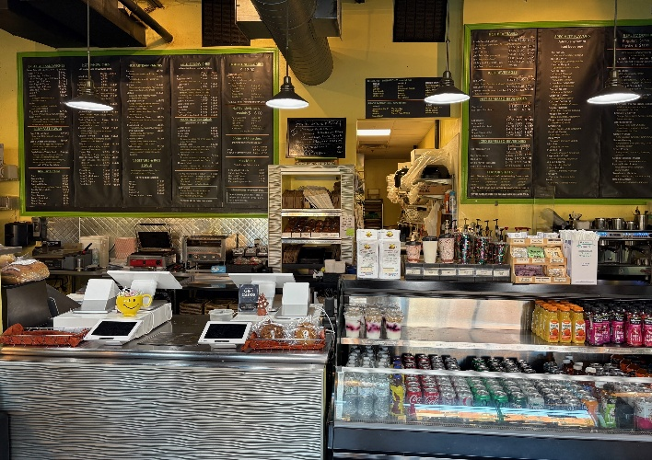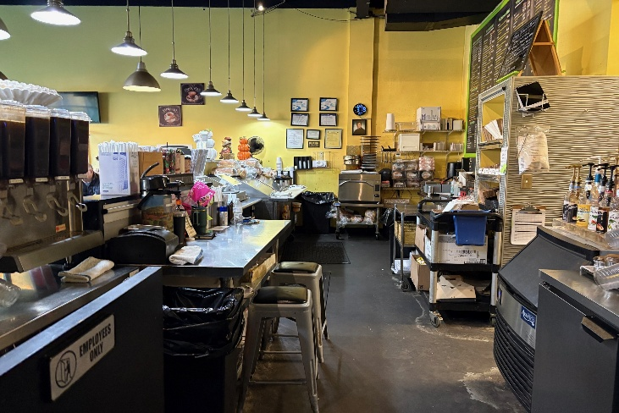
SELLING PRICE:$195KDOWN PAYMENT:$100K

SALES VOLUME: $15K/wk. Percentage Delivery:30%

LEASE:$4K/mo. (includingNNN) only 6% of sales4Years left: New Lease at the end

SQUARE FOOTAGE: approx. 1,800 sf.

HOURS OF OPERATION:mostly 7AM to2PM, (closed Sun.)

SEATING: 24 inside25 outside (large patio)

REASON FOR SELLING:Retiring

COMMENTS: WHAT’S BETTER THAN A CAPTIVE AUDIENCE?Located in a huge business park area. This is the first time in 11 years where this beautiful business has become available. Known for its high quality and fast service, customers come from long distances for this great place…all your usual breakfast items and the BEST of lunch items. Built at a cost of over $350,000, all you need is $100K to benefit from what’s being offered. If you have the experience and a desire to be your own boss, call for a tour.

Call John at 781-858-2343 or jkruggie@comcast.net.

