NATIONAL RESTAURANT EXCHANGE
(617)721-9655
DSerpone@comcast.net

LISTING INFORMATION

PLYMOUTH~MEXICAN CANTINA~SCRATCH KITCHEN & BAR
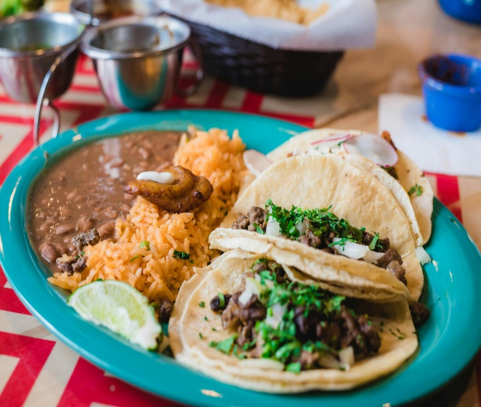

SELLING PRICE: $125K DOWN PAYMENT: only $50K

SALES VOLUME: $7K/wk off-season, $15K/wk in season ~~ no delivery

LEASE: only $2,750/mo. (includes NNN)

SQUARE FOOTAGE: approx. 2,000 sf.

HOURS OF OPERATION: 3 PM to 10 PM, (closed Sunday & Monday)

SEATING: 60 seats

REASON FOR SELLING: Family issues

COMMENTS: 7 stool bar is ready for a personable bartender. Known for their great food but lacking in advertising or promotions. This is SO CHEAP for a family to make their fortune. See it…you’ll love it.
Call Gina at 860-490-4483 or ginavarvelli@gmail.com

