NATIONAL RESTAURANTEXCHANGE
(617)721-9655
DSerpone@comcast.net

LISTING INFORMATION

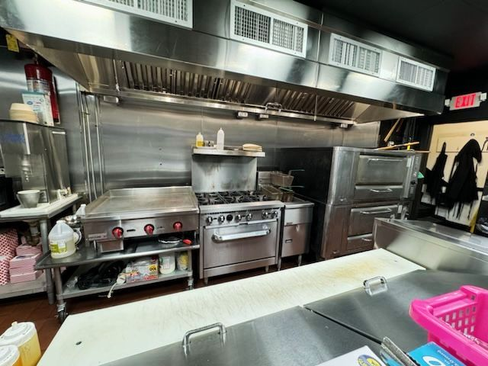
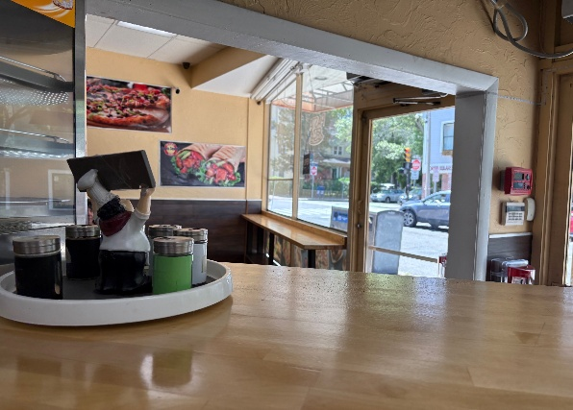
HOT~HOT DAVIS SQ. area, Somerville TUFTS College~~ Casual Italian Take-Out (Pizza, Subs, Wraps, Pasta)

(stock photos)

SELLING PRICE: $185K DOWN PAYMENT: $40k

SALES VOLUME: Strong $11K per wk..............60% Delivery

LEASE: $2,675/mo. includes NNN (only 5% of sales)
Yearsleft: 2.25 years + 5 years option to renew

SQUARE FOOTAGE:1,170

HOURS OF OPERATION: 6 days…Wednesday-Monday 11am-Midnight

SEATING: 10

COMMENTS: Davis Sq. is a major food & beverage mecca…the area draws from EVERYWHERE. This is a clean, simple operation with a strong repeat customer base.
The place lacks ‘personality’. Your investment will be back in your pocket within a couple of years. Check out the facility, go over the books…this is a rare opportunity to be part of the DAVIS SQUARE mystique.

