NATIONAL RESTAURANT EXCHANGE
978-715-5405

LISTING INFORMATION

MIDDLEBORO-BRIDGEWATER-area …BEER & WINE C-STORE

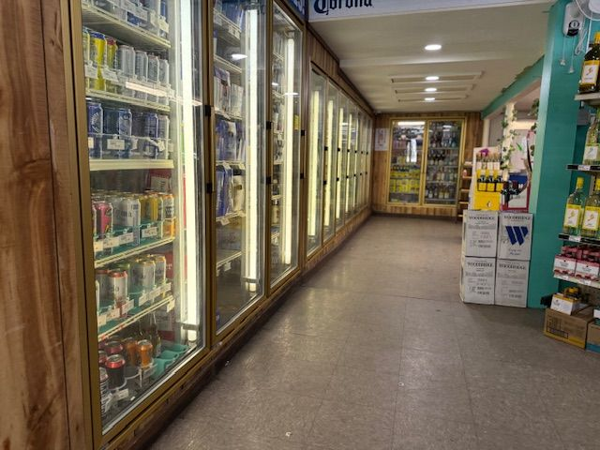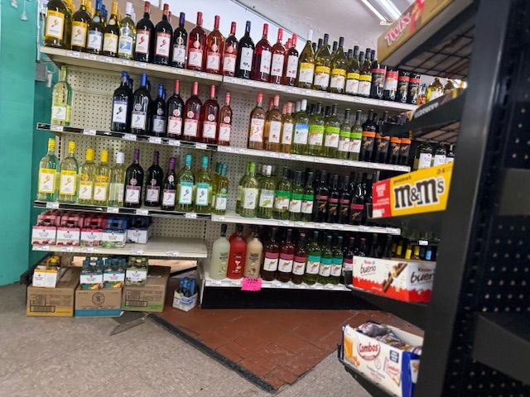

SELLING PRICE: $150K DOWN PAYMENT: $50K + inventory

SALES VOLUME: approx. $7K/wk (absentee owner)

LEASE: $3,500/mo. YRS. LEFT: new lease available

SQUARE FOOTAGE: 3,000 sf.

HOURS OF OPERATION: 7AM – 9 PM

ANNUAL LOTTERY COMMISSIONS: $50,000

COMMENTS: 40% of sales are BEER & WINE with an average mark-up of 40%. Owner since 2015, seller is totally ABSENTEE. Adjacent full commercial kitchen available for breakfast & lunch, pizza ovens (no competition). Adjacent kitchen is leased out $800/mo. +the full gas bill+ $100 for electricity, ½ phone/internet, and ½ trash. There’s over $100K in add-backs from seller.
Seller owns 5 acres and the bldg. with two beautiful apartments available for your help.

This is a great store to add to your chain or learn the business with your first store.

