NATIONAL RESTAURANTEXCHANGE
(617)721-9655
dserpone@comcast.com

LISTING INFORMATION

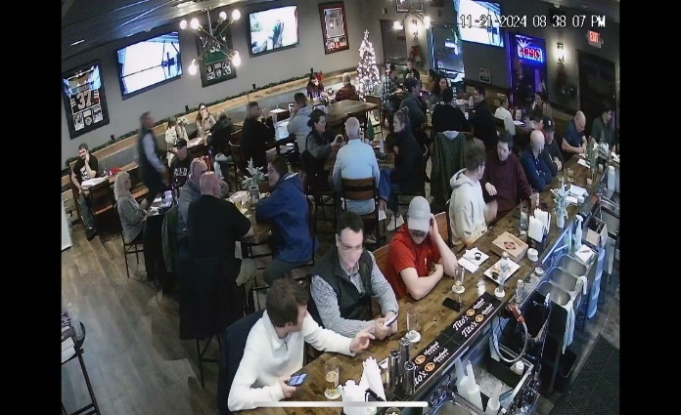

WORCESTER/SHREWSBURY Area~ Restaurant &Sports Pub W/Full Liquor

SELLING PRICE: $150,000 / $4.5 M w/Property
DOWN PAYMENT: $50,000
Downtown location, right off highway…flat ½ acre for apt. development…$4.5 M

Currently Closed…owner retired…loaded with all the equipment to open up as a restaurant or sports bar.

LEASE: New Lease available with an option on the real estate.

SQUARE FOOTAGE: 3,500sf. plus full dry basement

SEATING: (inside) 97...additional seating on sidewalk

REASON FOR SELLING: Retiring

COMMENTS: Long-standing neighborhood Pub. Located on a very heavily travelled street downtown, adjacent to a couple of major highways. Everything is in place and ready to go, just bring your staff. Parking for 100 cars, on a corner lot with plenty of visibility. The property is available as well. Ready for a major development or just run it as it is with several other retail spaces and offices on the upper levels.
Contact John at 781-858-2343 or jkruggie@comcast.net.

