NATIONAL RESTAURANT EXCHANGE
(617)721-9655
DSerpone@comcast.net

LISTING INFORMATION

NORTH SHORE~FIRST TIME OFFERED~FULL SERVICE RESTAURANT with 40-SEAT BAR (formerly a famous Irish Bar)
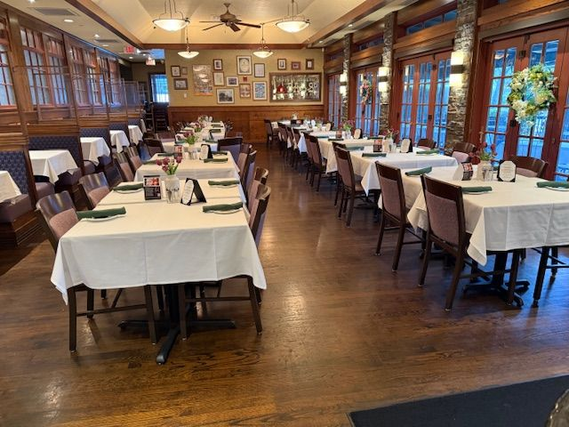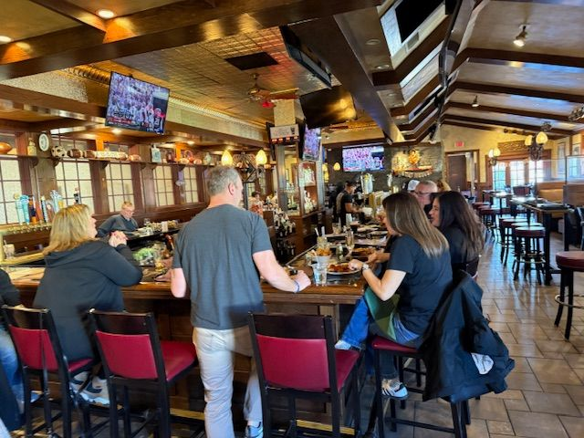

SELLING PRICE: $395K DOWN PAYMENT: only $125K~secondary
financing for $25K

SALES VOLUME: $45K/wk - $48K/wk ($2.4M for 2025)
LEASE: $13,000/mo (includes NNN) …3-yr OPTION TO BUY THE REAL ESTATE AT FAIR MARKET VALUE.
SQUARE FOOTAGE: approx. 6,000 sf footprint….with full 4,000 pristine basement, fully useable. HUGE parking lot,

HOURS OF OPERATION: 12 AM to 12 AM (Fri & Sat,), Sun till 10 PM, Tues,, Weds, Thurs. 4 to 10 PM., closed Mondays.

SEATING: 180 seats inside 40 outside patio Bldg. is fully sprinkled
REASON FOR SELLING: Retiring

COMMENTS: This is one of the finest restaurants on the North shore…top-shelf furniture, fixtures and kitchen equipment. Town sewerage. Excellent, long-term staff. HUGE parking lot. 50,000 cars per day pass by…HIGHLY VISIBLE. This is PERFECT dinner chain location whether Mexican, Brazilian, or Asian. With some decorative changes, this could be a sports bar. YOUR CASH INVESTMENT RETURNED IN 6 MONTHS!

Call Dennis at 617-721-9655 or dserpone@comcast.net

