NATIONAL RESTAURANT EXCHANGE
(617)721-9655
DSerpone@comcast.net

LISTING INFORMATION

LOWELL, Mass. AREA~ FAST FOOD GOLD MINE
WITH OR WITHOUT THE REAL ESTATE
(formerly a Taco Bell)

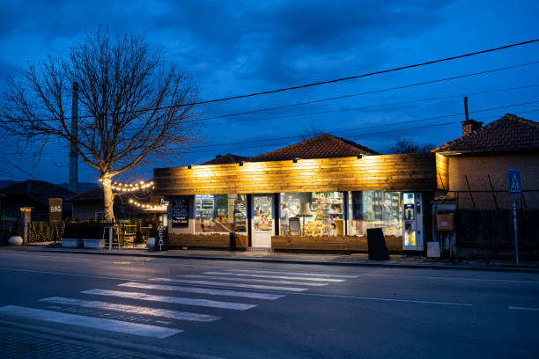

OUT-OF-STATE ABENTEE OWNER SAYS “DROP THE PRICE”

BUSINESS AND REAL ESTATE IS NOW ONLY $2.25M
… A SAVING OF$400,000! DOWN PAYMENT: 10% with SBA
financing readily available

SALES VOLUME: $50K+/wk Percentage Delivery: 30% DoorDash

SQUARE FOOTAGE: 2,000 sf. bldg. on a large lot and with a DRIVE THRU
HOURS OF OPERATION: 11AM to 2 AM (weekends)
SEATING: 16 seats…primarily ‘take out’ and drive thru.

Verifiable annual net profit: $400,000 + per year

Voted “BEST FAST FOOD IN MERRIMACK VALEY” for 2025

COMMENTS: Offers an extensive fast food menu including roast beef sandwiches, burgers, hot dogs, sandwiches (chicken, fish, pastrami, veal), tacos, burritos, fried foods, chili, shakes, soft serve ice cream, Pepsi fountain drinks, and bottled drinks.
Very experienced staff will stay... ABSENTEE OWNER LIVES IN FLORIDA…BUSINESS RUNS ITSELF.
Real estate appraised for $1.65M.

Call Dennis at 617-721-9655 or email: dserpone@comcast.net

