NATIONAL RESTAURANT EXCHANGE

*(617)721-9655*

DSerpone@comcast.net

# LISTING INFORMATION

**NATICK-FRAMINGHAM~~POPULAR BREAKFAST & LUNCH with PARKING**

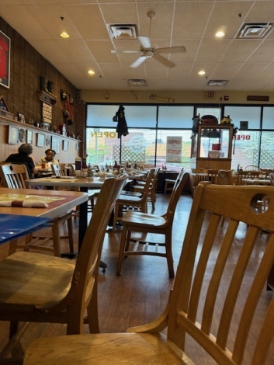 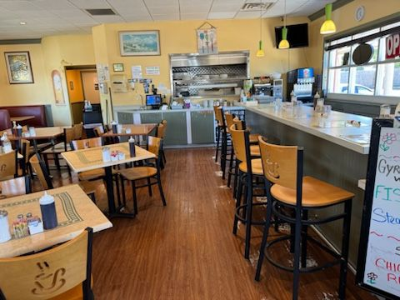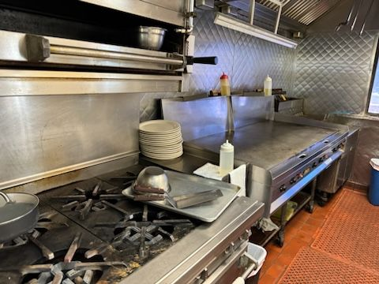

**SELLING PRICE:** $225,000 **DOWN PAYMENT: only $100K**

**SALES VOLUME: $11K - $13K/wk**

**LEASE:** $3,275/mo. **Years left**: new lease available

**SQUARE FOOTAGE:** 1,500sf.

**HOURS OF OPERATION:** 7 am -2 pm, 7 days.

**SEATING:** 50 plus 10 at a breakfast bar

**REASON FOR SELLING:** retiring

**Verifiable annual net profit:** approx. $100,000/yr.

**COMMENTS:**  This area needs a WAFFLE HOUSE. The day-part of breakfast overlapping into lunch is the most profitable segment of the food & beverage industry. Waffle House restaurants are huge throughout the South…next to none up here. What’s cheaper than flour & water? This is your chance to build a brand that’s easy to run yet wildly popular…and profitable. Your cash investment is back in your first year.

Take the time to see this rare opportunity.

**Contact Bob at** [**bobcioffi14@gmail.com**](mailto:bobcioffi14@gmail.com)**, or call 781-820-9288.**