NATIONAL RESTAURANTEXCHANGE
(617)721-9655
DSerpone@comcast.net

LISTING INFORMATION
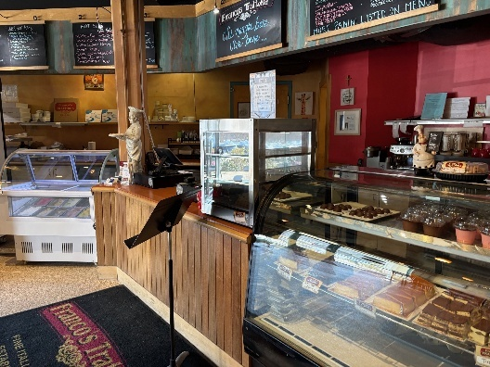
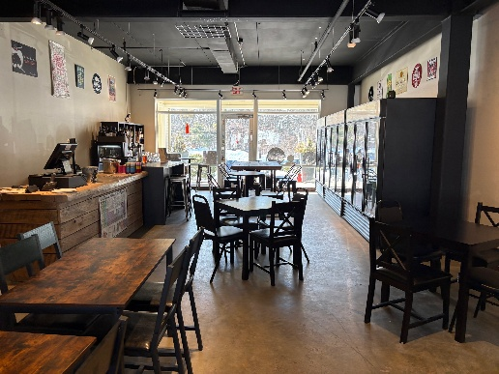
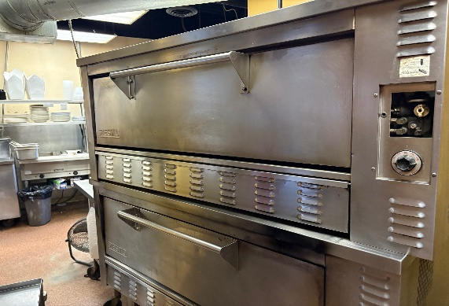

TYPE OF BUSINESS: Italian Trattoria

LOCATION:Greater Wayland Area

SELLING PRICE: $525,000DOWN PAYMENT:$200,000

SALES VOLUME: $23-25K/WK25% Delivery

LEASE:$5,900 / $3,700 inc. NNNYearsleft: 3 + 5

SQUARE FOOTAGE: 4,000+ basement for prep

HOURS OF OPERATION6 days 11-9 closed Mon.

SEATING: 40/48inside10

REASON FOR SELLING:New project

COMMENTS: Here’s a twofer you must see to believe.A Pizza Parlor with a Beer and Wine Lounge just a few steps away. Bring the kids for Pizza and Gelato while you sit and enjoy a glass of wine or a Craft Beer. Oh, and enjoy local entertainment Thurs threw Sat Nites. Enjoy stone hearth Neapolitan Pizza, Pasta and traditional Italian dishes in cozy familyatmosphere. It offers a little ones table for playing with crayons and their own 60 “TV. Kitchen in impeccable condition and a storage room in the basementwith a walk-in cooler an freezer. This is to good to believe.
Contact: John Ruggieri at 781-858-2343 or jkruggie@comcast.net

