NATIONAL RESTAURANT EXCHANGE
(617) 840-5606
Betsy817@verizon.net

LISTING INFORMATION
Somerville – Tufts Univ. Area-Seafood & Bar
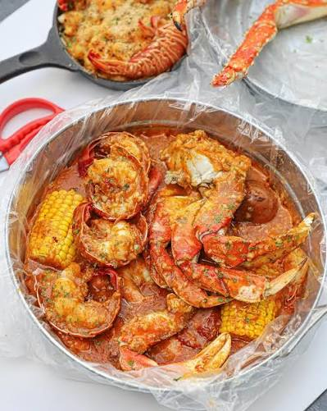

ASKING: $180K
SALES VOLUME: $13K WK.

LEASE: incredibly cheap at $4,000/mo.
SQUARE FOOTAGE: Approximately 1,000 sf.
SEATING: 28 Inside 2 seats & table outside.

HOURS OF OPERATION: 7 Days Sunday 12PM-10PM Mon.-Thur 3PM-10-PM
Fri. & Sat 12PM-11PM

COMMENTS: Everyone wants to own a beautiful bar in a college area. Walking distance to thousands of students at Tufts. Great visibility. Other local restaurants draw people to the area. Sellers are blessed with significant cash transactions. Excellent kitchen equipment with walk in cooler. Terrific variety of seafood choices. Very little advertising. Delivery.
If you’re ready to make a move check out this place!
Contact Betsy 617-840-5606 or betsy817@verison.net

