NATIONAL RESTAURANT EXCHANGE
(978)-715-5405 FAX: (339)-883-3027
nerestaurants@yahoo.com

LISTING INFORMATION

MEDFORD-ARLINGTON area BREAKFAST ONLY-CLOSES AT 1PM.

BUSY MAIN ROAD WITH LARGE PARKING LOT ACROSS STREET.

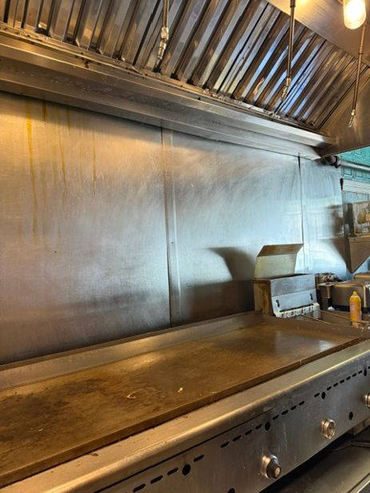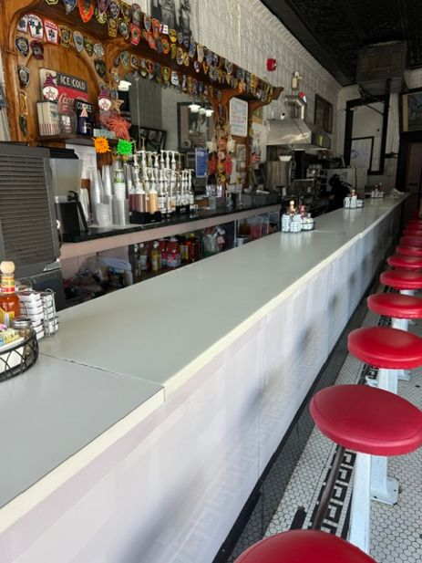

ASKING: $95K
DOWN PAYMENT: $50K

SALES VOLUME: $7K -$8K/wk.

LEASE: incredibly cheap at $1,800/mo. YRS. LEFT: New lease available

SQUARE FOOTAGE: Approximately 1,000 sf.
SEATING: 49 seats-booths and counter.

HOURS OF OPERATION: 6 AM – 1 PM

REASON FOR SELLING: Retiring after 37 years behind the grill!!!

COMMENTS: This is the first time that this place is available in 37 yrs. PRICES ARE BELOW MARKET AND SHOULD BE INCREASED BY AT LEAST 10%. Strong local customer base that come in almost every day. GOOD FOOD , CHEAP PRICES. After 37 yrs. some money is going to be spent upgrading the facility. Train depot is a block away.
BREAKFAST is the MOST PROFITABLE part of the industry.
Call Mr. Williams @ 978-715-5405 to meet the owner.

