NATIONAL RESTAURANT EXCHANGE
(617)721-9655 (781)246-5000
DSerpone@comcast.net DenSerpone@gmail.com

LISTING INFORMATION

MILFORD, NH ~~POPULAR PIZZA & SANDWICH OPERATION
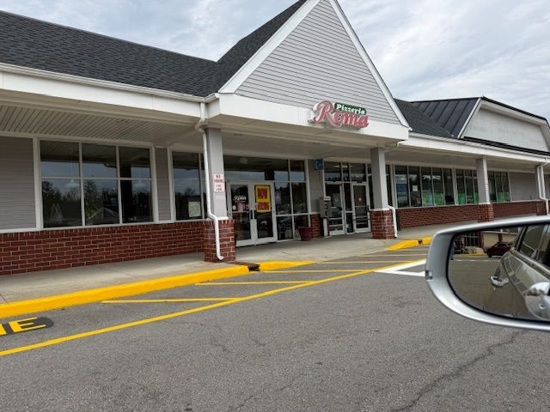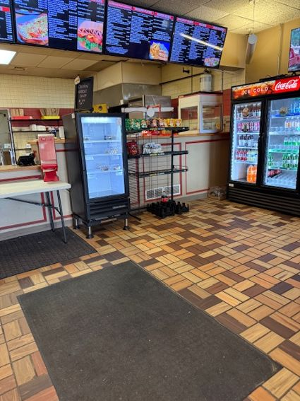

SELLING PRICE: Only $165K DOWN PAYMENT: only $90K

SALES VOLUME: $13K+ per week

LEASE: $4,300/mo (includes NNN) YRS. LEFT: 5 yrs.

SQUARE FOOTAGE: 2,500 sf. SEATING: 45 seats

HOURS OF OPERATION: 6days, 11AM to 9PM

VERIFIABLE ANNUAL NET INCOME: $100,000/yr

COMMENTS: This is the kind of a place that every pizza buyer wants…great visibility, right off a major highway, and a huge parking lot. Full liquor license is available to convert this facility into a PIZZA PUB.
Well-trained staff makes the transition easy.
Call Davine at 978-701-2034 or davinebechara@gmail.com

