NATIONAL RESTAURANT EXCHANGE
978-715-5405

LOWELL-area~~BUSY ROAST BEEF & PIZZA (interstate junction)
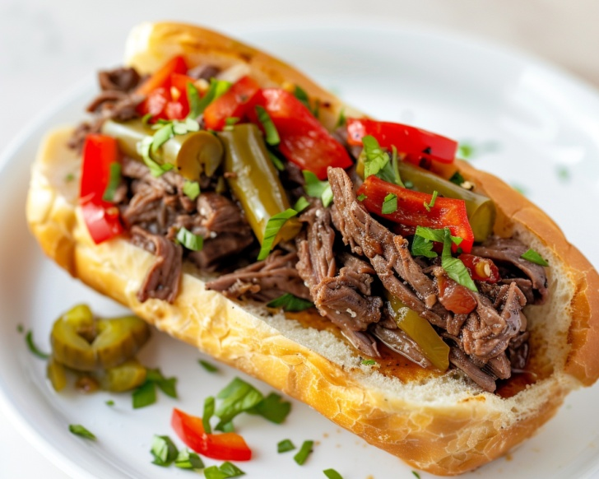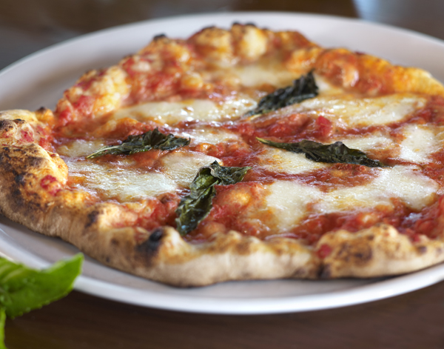

SELLING PRICE: $499K DOWN PAYMENT: $150K

SALES VOLUME: actually a solid $25K - $30K/wk

LEASE: $4,300/mo. (includes NNN) YRS. LEFT: new 10 yr. lease

SQUARE FOOTAGE: 1,000 sf.

SEATING: 20 seats…mostly pick up & t/o

HOURS OF OPERATION: 7 days, 10 AM – 9PM

VERIFIABLE ANNUAL NET INCOME: $250,000/ yr as ABSENTEE owner.

COMMENTS: Voted BEST ROAST BEEF in town. Fully trained and trustworthy staff will stay on. Think of the possibility if one or two working owners took over. 80,000 cars per day pass by your big roof sign. Located in a busy strip center with two major ‘draws’ to this site.
NOTE: Pizza is one of the most profitable foods you can serve. It's versatile, universally loved, and built on cost-effective ingredients like dough, sauce, and cheese.

