NATIONAL RESTAURANTEXCHANGE
(617)721-9655
DSerpone@comcast.net

LISTING INFORMATION

PLYMOUTH~MEXICAN CANTINA~SCRATCH KITCHEN & BAR
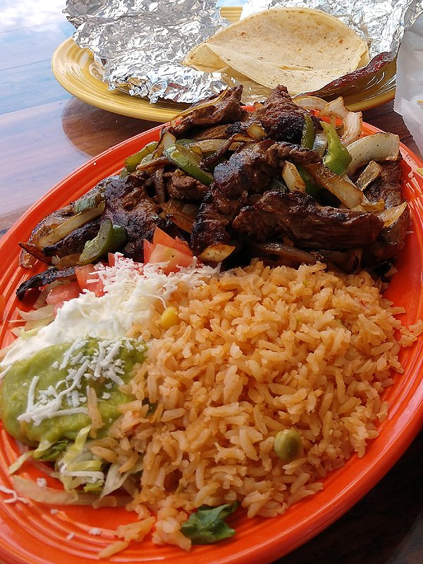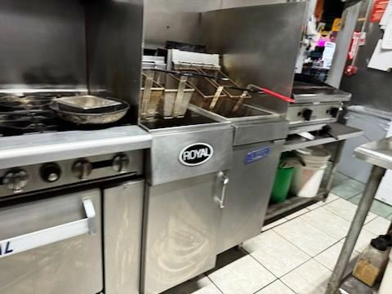

SELLING PRICE:$100KDOWN PAYMENT:only $25K

SALES VOLUME: $7K/wk off-season, $15K/wk in season ~~ no delivery

LEASE:only $2,750/mo. (includes NNN)

SQUARE FOOTAGE:approx. 2,000sf.

HOURS OF OPERATION:3 PM to 10 PM, (closed Sunday & Monday)

SEATING: 60 seats

REASON FOR SELLING: Family issues

COMMENTS: FULL LIQUOR & ENTERTAINMENT LICENSES. 7 stool bar is ready for a personable bartender. Known for their great food but lackCOMPETENT MANAGEMENT…no experience in advertising or promotions. This is SO CHEAP for a family to make their fortune. See it…you’ll love it. Food truck is available.

Call Gina at 860-490-4483 or ginavarvelli@gmail.com

