NATIONAL RESTAURANTEXCHANGE
(617)721-9655
DSerpone@comcast.net

LISTING INFORMATION
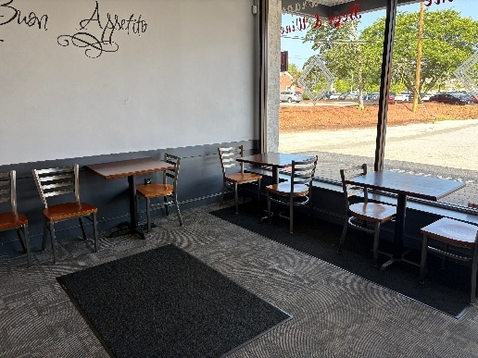
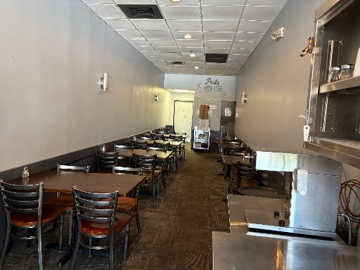
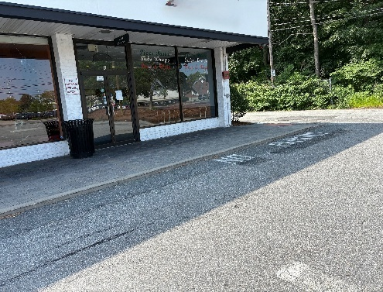

CHELMSFORD AREA~~ITALIAN RESTAURANT~~SPECIALITY ENTRES

SELLING PRICE: $175,000DOWN PAYMENT: $35,000

SALES VOLUME: $10-12K/wk% Delivery: none…mostly pick-up

LEASE: $3,000 + NNN ($650) Years left: 3 + 5 yrs

SQUARE FOOTAGE: 1600sf

HOURS OF OPERATION: 11 AM -8:30 PM… Tues – Sat.

SEATING: 36

REASON FOR SELLING:Retiring

COMMENTS: Italian style restaurant that could become any concept you may have, but very suited for a Roast Beef shop, Fried Chicken sandwich shop as well as a Korean BBQ menu or good old fashion Chinese take-out or sit-down.
Located in a very well-maintained Strip Mall very close to the center of town as well many offices and residential neighborhoods. Very reasonable rent. It has been operating for 30 years, and it is time for a change to give it a new feel. It was renovated seven years ago and still looks great. BEER & WINE LICENSE AVAILBLE. This could be a specialty PASTA HOUSE.

Contact John Ruggieri at 781-858-2343 or jkruggie@comcast.net

