NATIONAL RESTAURANTEXCHANGE
(617)721-9655 (781)246-5000
DSerpone@comcast.netDenSerpone@gmail.com

METRO WEST, LARGE SPORTS BAR, NIGHTCLUB, &FUNCTION FACLITY
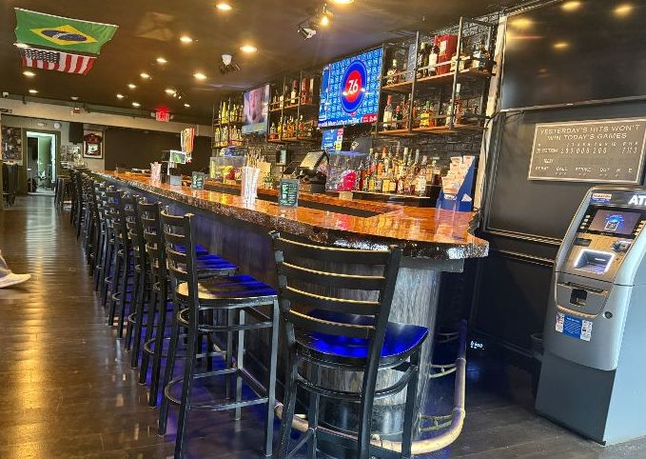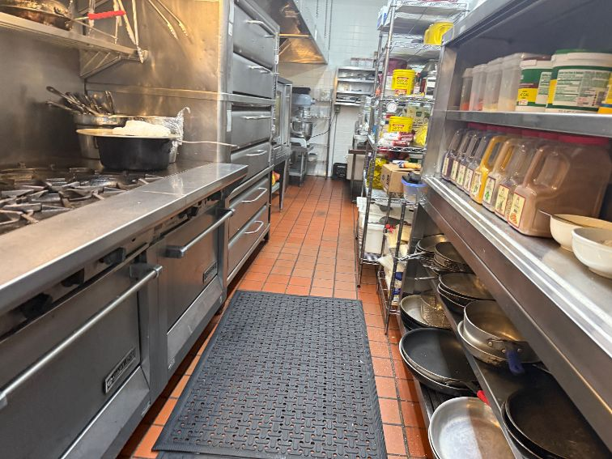
SELLING PRICE: $900K SBA financing readily available

SALES VOLUME: $50K - $60K per wk.

LEASE: $26,000/mo.

SQUARE FOOTAGE: two floors in use…approximately 6,000sf. per flr.

SEATING: 650 seats

HOURS OF OPERATION: 3PM – 1PM

ANNUAL LOTTERY &‘ATM’COMMISSIONS: approximately $100,000/yr.

REASON FOR SELLING: Other businesses require seller’s immediate attention.

VERIFIABLE ANNUAL NET INCOME: $500,000/yr.

COMMENTS: I’ve never seen a more complete sports bar, restaurant, nightclub and function facility. Live, international music acts and celebrities frequent this unique facility EVERY week. A huge, well-equipped kitchen and numerous walk-ins support an ease of operation. Located on a main street, with a huge parking lot, and great visibility. Strong, loyal staff earn above-average incomes. This is a perfect operation for two or more seasoned partners. You need to see it to believe it.

Call John Ruggieri at 781-858-2343 or jkruggie@comcast.net

