NATIONAL RESTAURANTEXCHANGE
(617)721-9655
DSerpone@comcast.net

LISTING INFORMATION
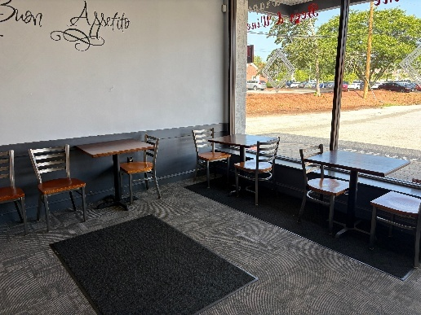
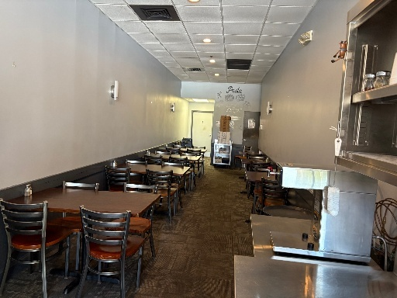
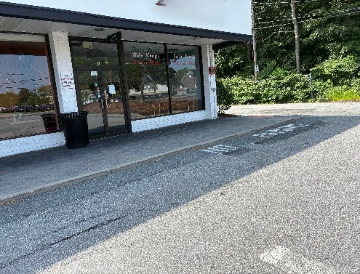

TYPE OF BUSINESS: ITALIAN TRATTORIA

LOCATION: Merrimack Valley

SELLING PRICE: $195,000DOWN PAYMENT: $100,000

SALES VOLUME: $10-12K/WK. None% Delivery

LEASE: $3,000 + NNN ($650) Years left: 3 + 5 yrs

SQUARE FOOTAGE: 1600 sf.

HOURS OF OPERATION 11-8:30 Tu. - SA

SEATING: 36inside

REASON FOR SELLING: Retiring

COMMENTS: Italian style Restaurant that could become any concept you may have, but very suited for a Roast Beef shop, Fried Chicken sandwich shop as well as a Korean BBQ menu or good old fashion Chinese take-out or sit-down. In a very well-maintained Strip Mall very close to the center of town as well many offices and residential neighborhoods. Very reasonable rent. It has been operating for 30 years, and it is time for a change to give it aa new feel. It was renovated seven years ago and still looks great.
Call John at781-858-2343 or email: jkruggie@comcast.net

