NATIONAL RESTAURANT EXCHANGE
(617)721-9655
DSerpone@comcast.net

LISTING INFORMATION

FOXBORO-area, COLLEGE TOWN PIZZERIA
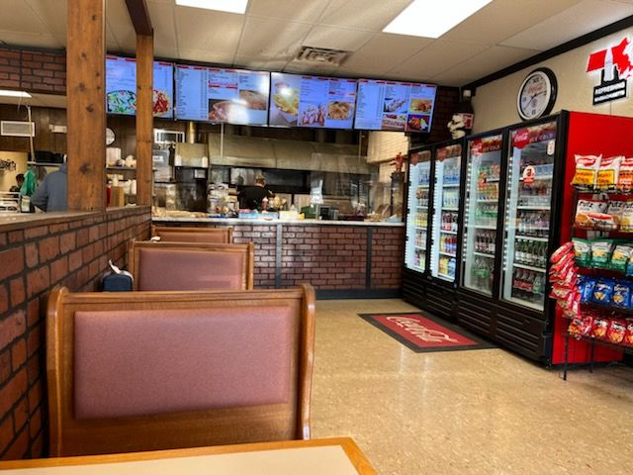

SELLING PRICE: $195K DOWN PAYMENT: only $75 K cash req’d
Seller to finance $95K @6% for 5 yrs., additional $25K financed 3 yrs at 12%

SALES VOLUME: Strong $12k/wk Percentage Delivery: 20%

LEASE: $5,400/mo (includes NNN)

SQUARE FOOTAGE: approximately 2,000 sf.

HOURS OF OPERATION: 11 AM to 8 PM

SEATING: 35 seats

REASON FOR SELLING: Young babies need parents at home (owners live 45 mins away)

COMMENTS: This franchised store has been owned for 8 yrs, close college with loads of apartments in the area. Continuation of franchise is optional and NOT suggested. Sellers invested $350K to build this beautiful Italian-style pizzeria. Top-shelf equipment.
Lack of consistent marketing on social platforms has hurt business. A season operator will see the hidden value of this facility and location.
Promo ideas: “Mondays: free cheese pizza with every order of 2 or more subs!...or with orders over $20!”

Call Dennis at 617-721-9655 or denserpone@gmail.com

