NATIONAL RESTAURANT EXCHANGE
(617)721-9655 (781)246-5000
DSerpone@comcast.net DenSerpone@gmail.com

LISTING INFORMATION

SHARON- LOOK!~~BREAKFAST and LUNCH LANDMARK- Nets 127K yr.

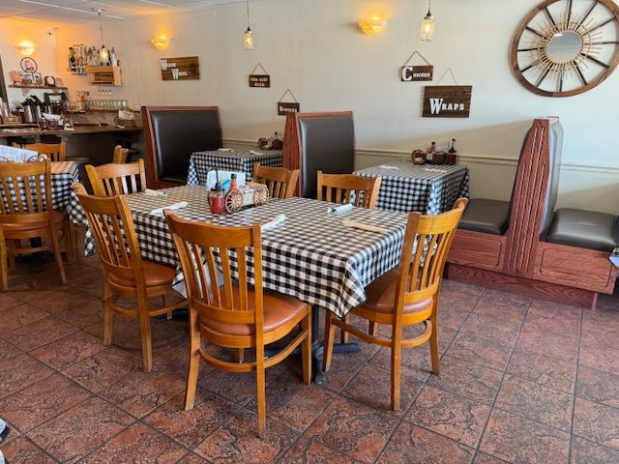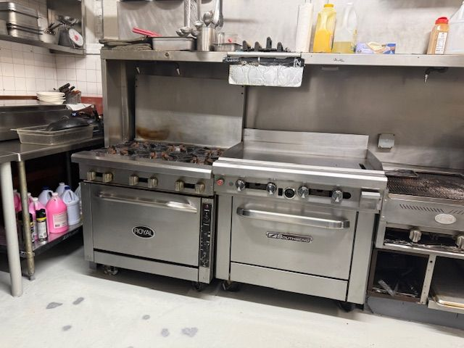

SELLING PRICE: $225K

DOWN PAYMENT: $100K

SALES VOLUME: $370K YR.

LEASE: $3,000 Mo. Inc. NNN…. New lease available.

SQUARE FOOTAGE: APPROX.1,600 sq ft.

SEATING: 50 seats.
HOURS OF OPERATION: 6AM-2PM.. (6-22-opening Mondays)/ closed Tuesdays.

COMMENTS: RARE-perfect opportunity for a family to ensure a great earning capacity while working for your own profitable business. Breakfast & Lunch, most profitable & controllable segments of the food & beverage industry. This is an exceptional, TURNKEY, clean & inviting facility for diners, w/breakfast counter. Great location with extensive parking and no Breakfast competition. Offering iconic RHODEY DOUGH (Dough boys) COFFEE (proprietary blend,) W/ Sunshine Breakfast & fruit cup, CHALLAH BREAD FRENCH TOAST & eggs your way. Put your personal stamp on this well-established business with tremendous upside. Owners pull $127k plus all benefits of owning your own business Seller financing, training and a huge established base. (has full liquor license for future expansion) Hurry, will not last.

Call Gina at 860-490-4483 or ginavarvelli@gmail.com.

