NATIONAL RESTAURANT EXCHANGE

LISTING INFORMATION

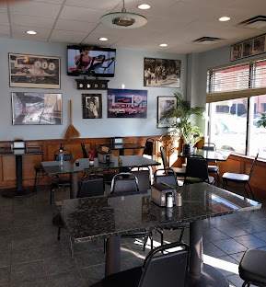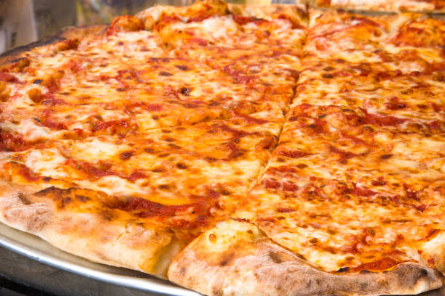

READING area PIZZERIA AND SANDWICH SHOP

SELLING PRICE: $300k DOWN PAYMENT: $159K Dn.

SALES VOLUME: STRONG $16K per wk. Percentage Delivery: 20%

LEASE: $3,500/mo (includes NNN)

SQUARE FOOTAGE: 1,200 sf.

HOURS OF OPERATION: 11 AM - 8PM

SEATING: 22 inside 12 outside

REASON FOR SELLING: Ownership of a lot of acquired real estate now requires more attention.

COMMENTS: This is a beauty. Great staff will stay on. This is perfect for two brothers or a husband & wife. Great town, close to train terminal. Best NY style Pizza around
Take a minute to see it, you will love it.

Call Mr. Williams @ 978-715-5404 or email nerestaurants@yahoo.com

