NATIONAL RESTAURANT EXCHANGE

*(617)721-9655* DSerpone@comcast.net

# RARE OPPORTUNITY

# FOR SEASONED SPORTS BAR OPERATORS

# TO TAKE OVER THIS MILLION DOLLAR PALCE

**MEDFILD AREA~SPORTS BAR**

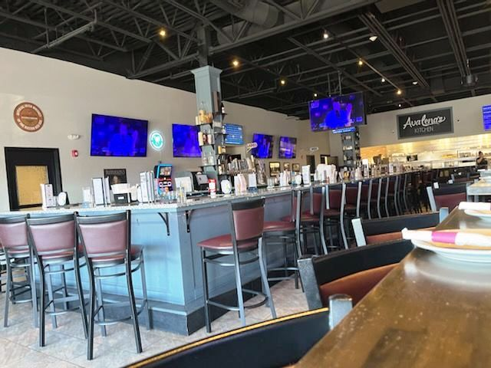 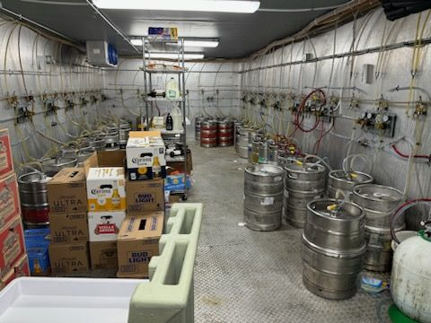

**SELLING PRICE:** $230,000 **DOWN PAYMENT: $**115,000

**SALES VOLUME:** $28K - $32K/wk

**LEASE:**$7,500/mo includes NNN **Years left:**2 yrs + 2/5yr. options

**SQUARE FOOTAGE:** 6,200sf.

**HOURS OF OPERATION:** 7days: M-T 4-10, Th-S 12-1, Sun 12-9

**SEATING:** 300 seats (includes meeting room)

**COMMENTS: THIS IS THE ULTIMATE SPORTS BAR. The open floor plan and bar area is surrounded by huge TVs on all of the walls with a state-of-the-art sound system. Live entertainment on the weekends. The bar features over 30 draft beers that are kept cold in the biggest draft beer cooler you may ever see. The menu covers the gamut from wood fired pizza to seafood and more. Long term lease and a motivated seller. HUGE PARKING. THIS THE BEST THAT $115,000 CAN BUY**

**…bar, restaurant experienced required. Call for details.**

**Contact Dennis @ (617) 721-9655 or dserpone@comcast.net**