NATIONAL RESTAURANTEXCHANGE
(617)721-9655
DSerpone@comcast.net

Greater Wayland Area ~~ Italian Trattoria PRICED TO SELL
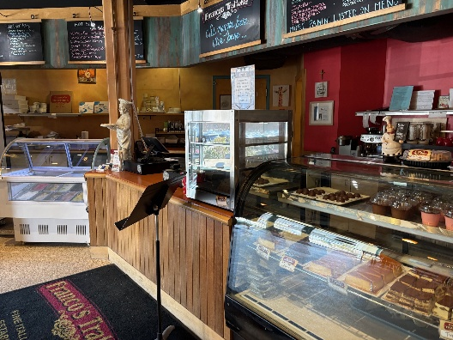
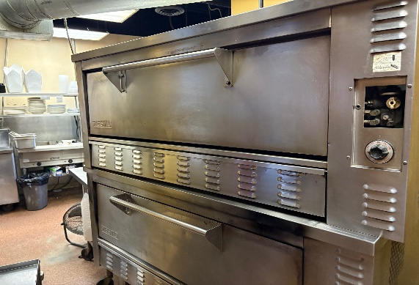

SELLING PRICE: $395,000

DOWN PAYMENT: $200,000
or an SBA loan with only 10% down.

SALES VOLUME: $23-25K/wk. ($1.3M/yr) 25% Delivery

LEASE: $5,900/mo. (inc. NNN) fabulous~ only 5% of sales. Years left: 3 + 5

SQUARE FOOTAGE: 4,000 sf. + basement for prep

HOURS OF OPERATION: 6 days, 11-9, closed Mon. EXCELLENT STAFF

SEATING: 40 seats inside, 10 seats on patio

COMMENTS: Here’s a PIZZA PARLOR with a Beer and Wine license.

“Priced below market value”. Very popular with the kids in the neighborhood for PIZZA and GELATO! This Pizzeria is known for its stone- hearth Neapolitan pizza, pasta and traditional Italian dishes in a cozy family atmosphere. It has a children’s table for playing with crayons and their own 60 “TV to keep the kids occupied. The kitchen is in impeccable condition and there’s a nice size storage room in the basement with a walk-in cooler and freezer. This is just too good to believe. If you take the time to see this, you’ll want to put on an apron and start making pizzas. Excellent seasoned staff that will stay on along with support from the present owner makes this an excellent choice and investment.

Contact: John Ruggieri at 781-858-2343 or jkruggie@comcast.net

