**National Restaurant Exchange**

**978-715-5405 FAX: 339-883-3027**

**WORCESTER ~ POPULAR ITALIAN RESTAURANT since 1964**

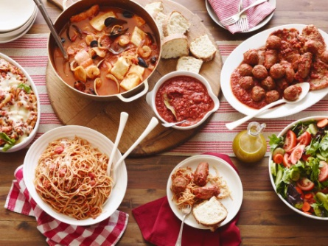

**SELLING PRICE:**       $295K       **DOWN PAYMENT:**$100,000

**SALES VOLUME:  $25K - $30K/wk…consistently**

**LEASE**:  $6,500/mo. (includes NNN)  **Years left:**3 yrs.+ 5+ 5

**SQUARE FOOTAGE:  6,000**sf. (huge kitchen with excellent equipment)…**SPRINKLED**

**HOURS OF OPERATION:**7 days, 11 – 9 pm (great staff will stay on)

**SEATING:**175 inside 50 outside patio

**REASON FOR SELLING**: retiring

**COMMENTS:    ‘BYOB’… full liquor license is available.  Customers come from EVERYWHERE for their ‘tripe’ and stuffed ‘everything’. No competition in the area. Located on a very busy main road near MASS PIKE exit makes it easy to get to.**

If you have the experience and the money, **I guarantee that when you see this gem…YOU’LL BUY IT. Call 978-715-5405 to meet the owner.**